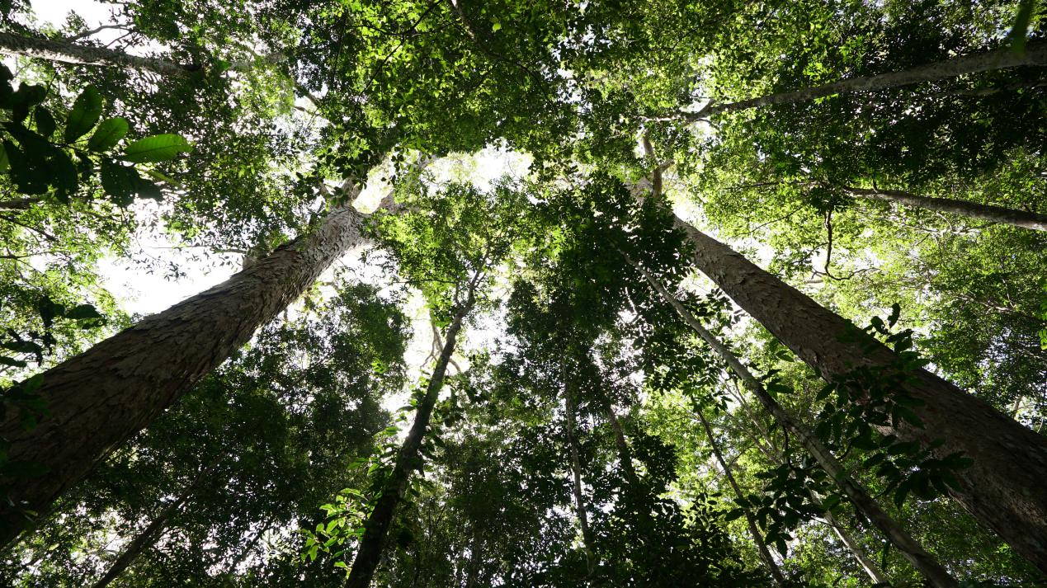

Figure. Giant trees located in the Jari river region in Brazilian Amazon during Jari-Paru Expedition in 2019.

Credit: Jari-Paru 2019 Expedition.